TOPS Online

District Manual

Version 1.0

Overview 3
System Requirements 3
Prerequisite Information 4
• Explanation of Travel Order Status 4
Using TOPS Online 5
• Requesting Access 5
• Logging In 5
• Changing Your Password 6
• Creating a Travel Order 6
• Editing a Travel Order 6
• Deleting a Travel Order 6
• Viewing a Travel Order 7
• Creating a Transportation Agreement Form 8
• Checking the status of your Travel Orders 8
• Logging Out 8
• Using Help 8

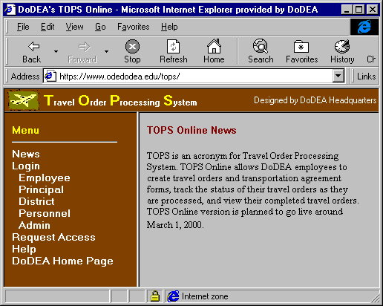
Overview

The Travel Order Processing System Online (TOPS Online) is designed to assist Department of Defense Education Activity (DoDEA) field employees in initiating, submitting, and receiving Travel Order forms for non-TDY travels.

TOPS Online will enhance the automation that currently exists in the Personal Computer (PC) based TOPS by taking advantage of the Internet. Employees will be able to visit the TOPS Online web site, log in, then create and check the status of their travel orders 24 hours a day. TOPS will assist the employee in filling out the Travel Order form (DD 1614) and Transportation Agreement forms (DD 1616, DD 1617, and DD 1618) with all the default values in place so that the employee will only have to add any additional information and comments he/she wishes to convey to the DoDEA Personnel Center.

Once a Travel Order has been submitted, the DoDEA Personnel Center will immediately have it for processing. When processing is finished, the employee will be notified via email that he/she can visit the TOPS Online web site and view/print their completed Travel Order. The employee will also be able to view/print all previous Travel Orders processed with the PC based TOPS.

TOPS Online, however, cannot handle accompanied documents that are required for certain Travel Order types. For example, a copy of a college’s letter still must be faxed in when submitting a Travel Order form for Educational Travel; a signed copy of the Transportation Agreement form still must be faxed in for Renewal Agreement Travel, etc.

System Requirements

To use TOPS Online you will need:
- a PC with Internet access
- an Internet browser
We recommend you use Microsoft Internet Explorer 4.0 or later release. You can use Netscape Navigator 4.04 or later release but you will need an extra browser plug-in, NCompass Labs ScriptActive 2.9.0.1 or later release. This plug-in is not free. For more information, please visit NCompass Lab’s web site.

Prerequisite Information

Explanation of Travel Order Status

A Travel Order’s status identifies where it is in the chain of processing. There are eleven different statuses.
- Draft – A Travel Order with status “Draft” has been created but has not yet been submitted to DoDEA Personnel Center for processing. You can still change the data or delete it.
- Pending – A Travel Order with status “Pending” means that the Requesting Official has put the Travel Order on hold until supporting documentation is received by the DoDEA Personnel Center.
- Submitted – A Travel Order with status “Submitted” has been submitted to the DoDEA Personnel Center for processing. The Employee, Principal or District user cannot change this order. However, if you feel that you have provided information that might need changing and the status of the Travel Order is not ‘Completed’, you can submit an email message to your Personnel Center Personnel Management Specialist requesting a change. Once the Travel Order is marked ‘Completed’, changes will require an amendment.
- Verified – A Travel Order with status “Verified” has been reviewed by a Requesting Official at DoDEA Personnel Center.
- Req. Signed – A Travel Order with status “Req. Signed” has been signed by a Requesting Official at DoDEA Personnel Center and sent to an Approving Official.
- Appr. Signed – A Travel Order with status “Appr. Signed” has been signed by an Approving Official at DoDEA Personnel Center and sent to fiscal for fund citing.
- Appr. Signed (?) – A Travel Order with status “Appr. Signed (?)” has been sent back to the Approving Official by fiscal for review.
- Fund Cited – A Travel Order with status “Fund Cited” has had the fund citation supplied and has been sent to the Authorizing Official.
- Fund Cited (?) – A Travel Order with status “Fund Cited (?)” has been sent back to the fund cite supplier for review.
- Fiscal Signed – A Travel Order with status “Fiscal Signed” has been signed by the Authorizing Official and is awaiting distribution by the Approving Official.
- Completed – A Travel Order with status “Completed” has had its final review and been distributed by the Approving Official.
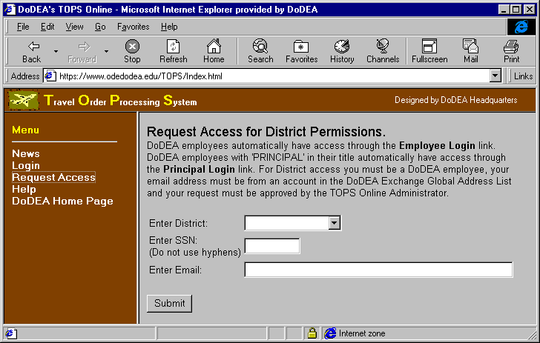

Using TOPS Online

Requesting Access

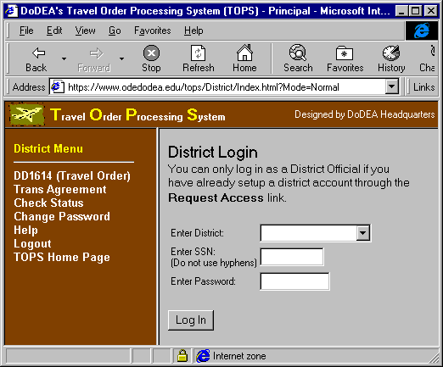
A user with District access has the ability to create, edit, delete and view all Travel Orders within the user’s District. To gain District access, a user must request it. To request District access, open your Internet browser, type https://hq-w4.odedodea.edu/tops in the address field and press the Enter key. On the left side of your browser, you will see a menu with a link titled “Request Access”. Click on that link. You will see on the right-hand side of your browser, an input screen for you to enter the District you are requesting access for, your SSN and your email address. Enter the information requested (your email address must be an email on the DoDEA Global Address List in Outlook.) When finished, click on the “Submit” button. Your information will be reviewed and a response will be sent to the email address you entered notifying you whether you have been granted access or not.

Logging In

To log into TOPS Online as a District Official, you must be a DoDEA employee who has previously requested District access, been approved and had a District account setup by the TOPS Administrator. You cannot access TOPS Online as a District Official until a District account is setup for you.

Open your Internet browser, type https://hq-w4.odedodea.edu/tops in the address field and press the Enter key. On the left side of your browser, you will see a menu with a link titled “Login”. Click on that link. You will see 5 more links appear underneath the “Login” link, “Employee”, “Principal”, “District”, “Personnel”, and “Admin”. Click on the “District” link. On the right side of your browser you will see a place to enter the DoDEA district you are assigned, your SSN and your password. The first time you log into TOPS Online, your password is ‘password’. Enter all items and click on the “Log In” button. If the information you entered matches the information contained in the TOPS Online users database, a welcome screen will appear in the right-hand side of your browser with your name in the title. If the information you entered is not in TOPS Online users database, you will see the log in screen with red letters stating your login attempt failed. If it is the first time you have logged into TOPS Online, you will be notified that your password has been changed. If not, you will be notified what the problem was and prompted to change your password again.

Changing Your Password

To change your password, click on the “Change Password” link in the menu section. You will see an input screen appear in the right-hand side of your browser. Enter your current password, your new password and your new password again in the fields provided and click on the “Save” button. If your current password matches the password in the TOPS Online users database and the new passwords you entered match each other, you password will be change to the new password.

Creating a Travel Order

Once you have logged into TOPS Online, you can create Travel Orders for yourself or anyone in your district. To create a Travel Order, click on the “DD1614 (Travel Order)” link on the left-hand side of your browser. You will see a new set of links appears; “Create”, “Edit”, “Delete”, and “View”. Click on the “Create” link. On the right-hand side of your browser you will be prompted to select a Travel Order type and to enter the SSN of the person for which you are creating the Travel Order. Select the Travel Order type, enter the SSN and click on the “Select” button. Next you will see an input screen for the Travel Order type you selected with some default information already entered. Below the input area are three buttons labeled “Save”, “Submit” and “Reset”. When you click on the “Submit” button, you will send the Travel Order to the DoDEA Personnel Center for processing. You cannot modify a Travel Order once it has been submitted. If you are not ready to submit the Travel Order you should click on the “Save” button. When you click on the “Save” button, you can save your Travel Order so that you can edit it at a future date.

Editing a Travel Order

You can only edit Travel Orders that you have created and not yet submitted. To create a Travel Order, click on the “DD1614 (Travel Order)” link on the left-hand side of your browser. You will see a new set of links appears; “Create”, “Edit”, “Delete”, and “View”. Click on the “Edit” link. You will see a query screen in the right-hand side of your browser. You can search for Travel Orders by any combination of the following: DoDEA Location, Travel Order Type, Travel Order Number, SSN or any portion of the Name. Enter the criteria you wish to search and click on the “Search” button. A list of Travel Orders that meet the criteria you entered and have the status “Draft” will be listed on the right-hand side of your browser. Click on the underlined name of the Travel Order you wish to edit. Next, you will see an input screen for the Travel Order selected with the information you already entered. Below the input area are three buttons labeled “Save”, “Submit” and “Reset”. When you click on the “Submit” button, you will send the Travel Order to the DoDEA Personnel Center for processing. You cannot modify a Travel Order once it has been submitted. If you are not ready to submit the Travel Order you should click on the “Save” button. When you click on the “Save” button, you can save your Travel Order so that you can edit it at a future date.

Deleting a Travel Order

You can only delete Travel Orders that you have created and not yet submitted. To delete a Travel Order, click on the “DD1614 (Travel Order)” link on the left-hand side of your browser. You will see a new set of links appears; “Create”, “Edit”, “Delete”, and “View”. Click on the “Delete” link. You will see a query screen in the right-hand side of your browser. You can search for Travel Orders by any combination of the following: DoDEA Location, Travel Order Type, Travel Order Number, SSN or any portion of the Name. Enter the criteria you wish to search and click on the “Search” button. A list of Travel Orders that meet the criteria you entered and have the status “Draft” will be listed on the right-hand side of your browser. Click on the underlined name of the Travel Order you wish to delete. Next, the information about the Travel Order will be displayed on the right-hand side of your browser and you will be asked if you are sure you want to delete the Travel Order. Click on the “Delete” button to delete the Travel Order.

Viewing a Travel Order

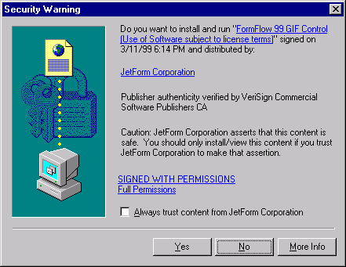
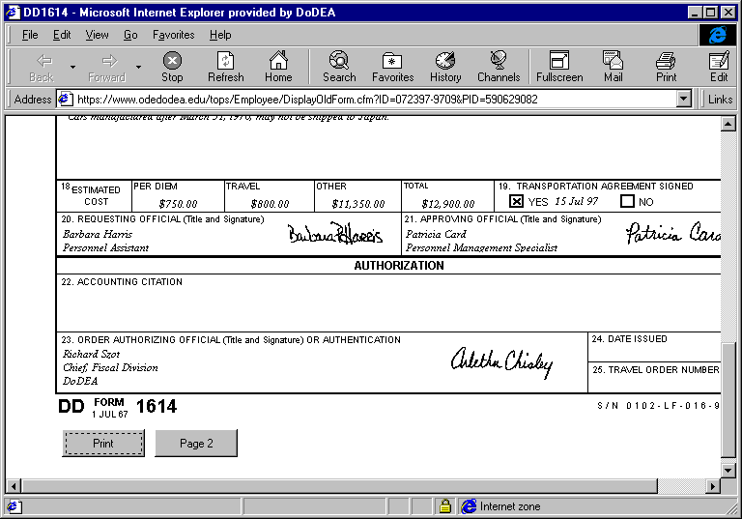
You can only view Travel Orders that have been processed by the DoDEA Personnel Center and marked as “Completed”. To view a completed Travel Order, click on the “DD1614 (Travel Order)” link on the left-hand side of your browser. You will see a new set of links appears; “Create”, “Edit”, “Delete”, and “View”. Click on the “View” link. You will see a query screen in the right-hand side of your browser. You can search for Travel Orders by any combination of the following: DoDEA Location, Travel Order Type, Travel Order Number, SSN or any portion of the Name. Enter the criteria you wish to search and click on the “Search” button. A list of Travel Orders that meet the criteria you entered and have the status “Completed” will be listed on the right-hand side of your browser. Click on the underlined name of the Travel Order you wish to view. A new browser window will be opened with the Travel Order you selected displayed. To see the back page, pull the tab on the right-hand side scroll bar down to the bottom of the window. You will see two buttons: “Print” and “Page 2”. If you click on the “Page 2” button, page 2 of the Travel Order will be displayed in the same window. By scrolling down to the bottom of the window, you will notice that the two buttons now read: “Print” and “Page 1”. If you click on the “Page 1” button, page 1 of the Travel Order will be displayed in the same browser window. To print the Travel Order, click on “Print” button located on the bottom of the page. You will be prompted to select which printer to print the Travel Order.

The first time you view a completed Travel Order you will see two windows (one pictured on the left), prompting you to install two plug-ins. Click on the “Yes” button for both plug-ins. Once installed, you will not be prompted to install these two plug-ins again.

Creating a Transportation Agreement Form

To create Transportation Agreement forms, click on the “Trans Agreement” link on the left-hand side of your browser. You will see a new set of links appears; “DD1616 (TP)”, “DD1617 (GS)”, and “DD1618 (State Side)”. Click on the Transportation Agreement form link that applies to you. You will be prompted to enter an SSN for which to print a Transportation Agreement form. Next, an input screen will appear in the right-hand side of your browser. Fill in the data and select the Travel Order for which you are creating the Transportation Agreement by clicking on the radio button in the Select column. When finished, click on the “Select” button. A new browser window will open containing the Transportation Agreement form. To see the back page, pull the tab on the right-hand side scroll bar down to the bottom of the window. You will see two buttons: “Print” and “Page 2”. If you click on the “Page 2” button, page 2 of the Transportation Agreement will be displayed in the same window. By scrolling down to the bottom of the window, you will notice that the two buttons now read: “Print” and “Page 1”. If you click on the “Page 1” button, page 1 of the Transportation Agreement will be displayed in the same browser window. If you click on the “Print” button, on either “Page 1” or “Page 2”, you will be prompted to select the printer you want the Transportation Agreement will be printed.

Checking the status of your Travel Orders

You can view the status of all of the Travel Orders at any time. To view the status of your Travel Orders, click on the “Check Status” link on the left-hand side of your browser. You will see a query screen in the right-hand side of your browser. You can search for Travel Orders by any combination of the following: Travel Order Type, Travel Order Number, SSN or any portion of the Name. Enter the criteria you wish to search and click on the “Search” button. A list of all of Travel Orders that meet the criteria you entered will be listed on the right-hand side of your browser. The status of each Travel Orders is listed in the last column on the right. If you have any Travel Orders with Status “Completed”, you will notice that the name field of those Travel Orders is underlined. Click on the underlined name to view the Travel Order.

Logging Out

It is important to log out of TOPS Online when you are finished working with your Travel Orders. To log out of TOPS Online, click on the “Logout” link on the left-hand side of your browser. You will be logged out of TOPS Online and your browser will display the TOPS Online home page.

Using Help

The TOPS Online Help web page has answers to Frequently Asked Questions (FAQs) and links to administrative and technical support. To access TOPS Online Help web page, click on the “Help” link on the left-hand side of your browser. If you are having a problem, the first thing you should do is check out the FAQs web page. To access the FAQs web page, click on the “FAQs” link on the left-hand side of your browser. You will see a list of questions appear on the right-hand side of your browser. You can see the answer to any question listed by clicking on it. Browse the questions to see if there are any questions that apply to the problem you are experiencing. If not, you can review the Joint Travel Regulation Volume 2 or the Department of State Standardized Regulations, which have links located in the Admin Support web page. To get to the Admin Support web page, click on the “Admin Support” link on the left-hand side of your browser in the TOPS Online Help web page. If that does not help you with the problem you are experiencing; you can submit a technical question via the Tech Support web page. To access the Tech Support web page, click on the “Tech Support” link on the left-hand side of your browser in the TOPS Online Help web page. Read the information displayed on the right-hand side of your browser. If you want to submit a question, click on the “here” link in the right-hand side of your browser. You will see the “Submit Question” page. Enter all of the information requested, and click on the “Submit” button. Your question will be submitted to DoDEA Information Technology to be answered.

